1. Uzum promo categories

**URL:** https://api.uzum.uz/api/main/promo-categories

**Метод:** GET

**Статус код:** 200 OK

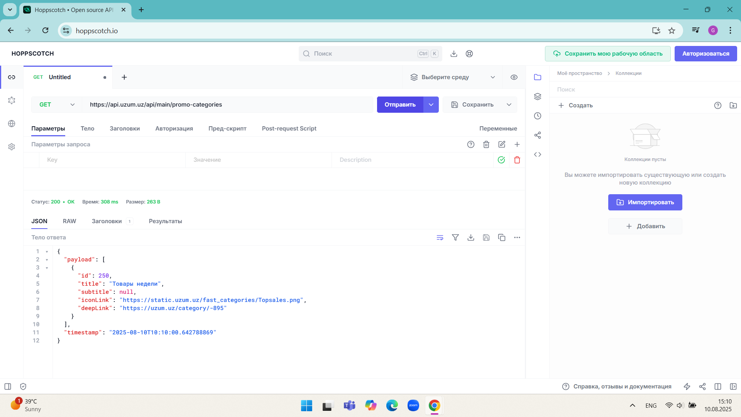

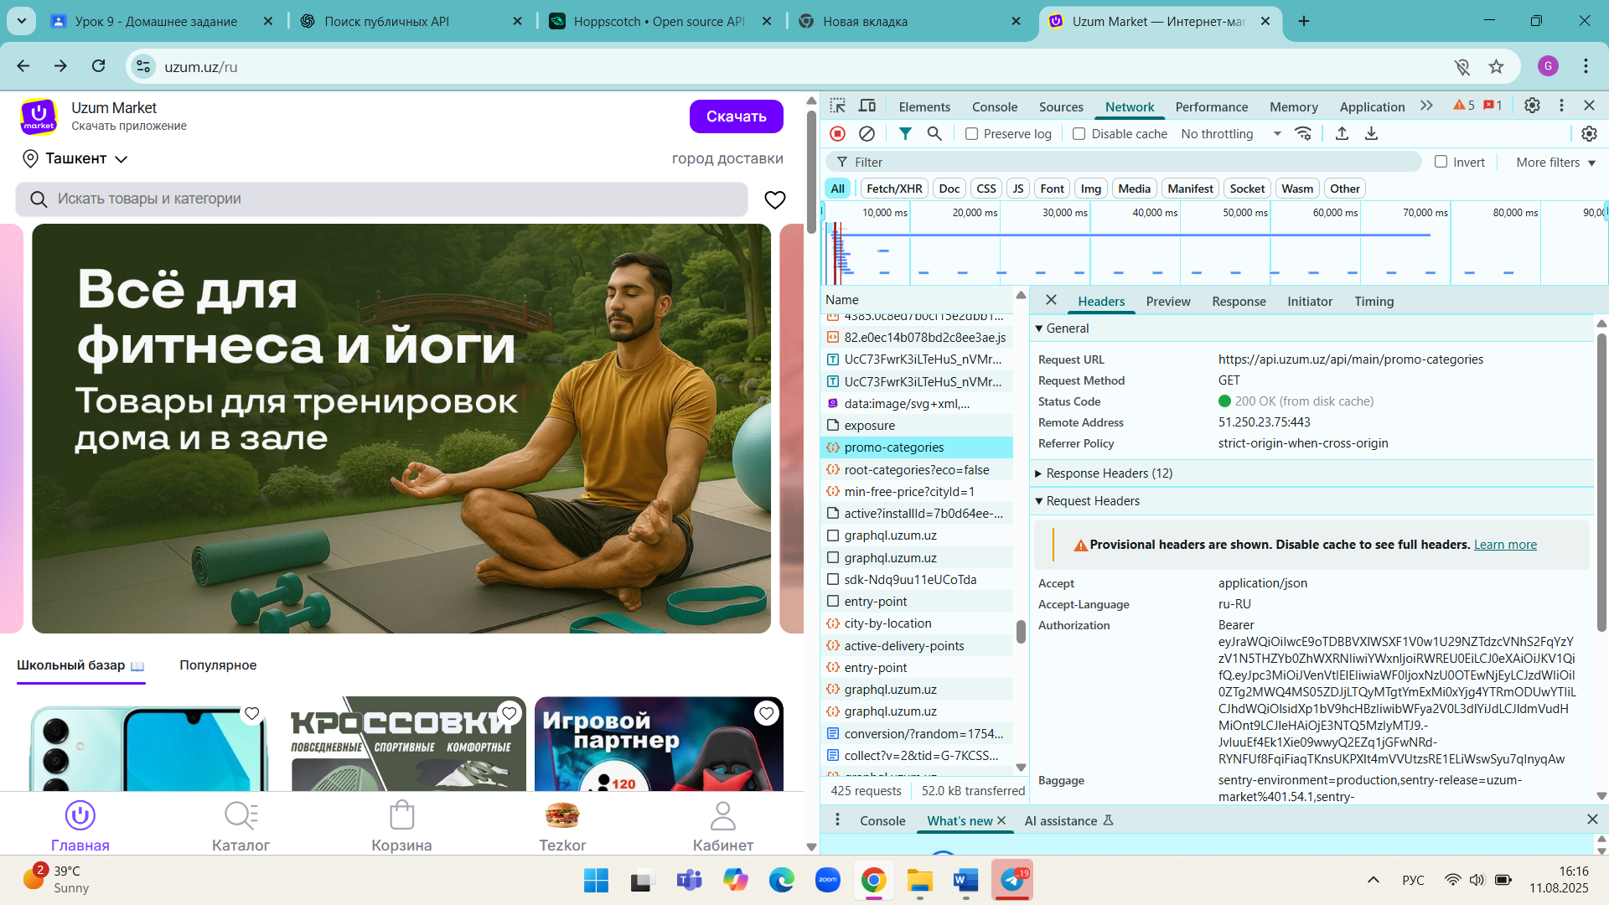

1. Wildberries школьный заезд

**URL:** https://static-basket-01.wbcontent.net/vol0/data/promotions/shkolniy-zaezd-uz-ru-v3.json

**Метод:** GET

**Статус код:** 200 OK

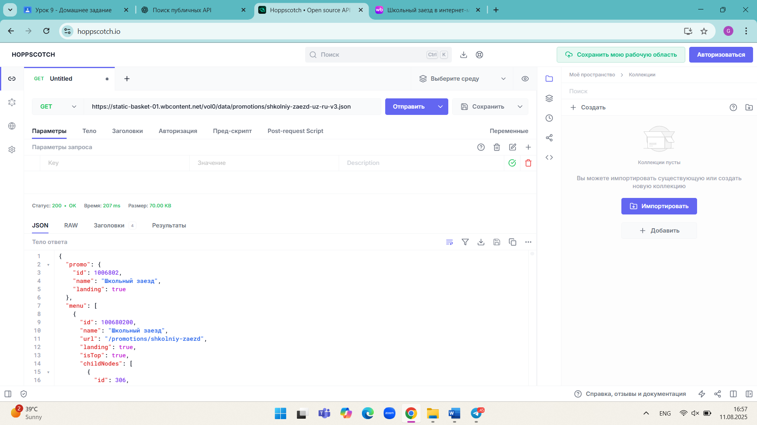

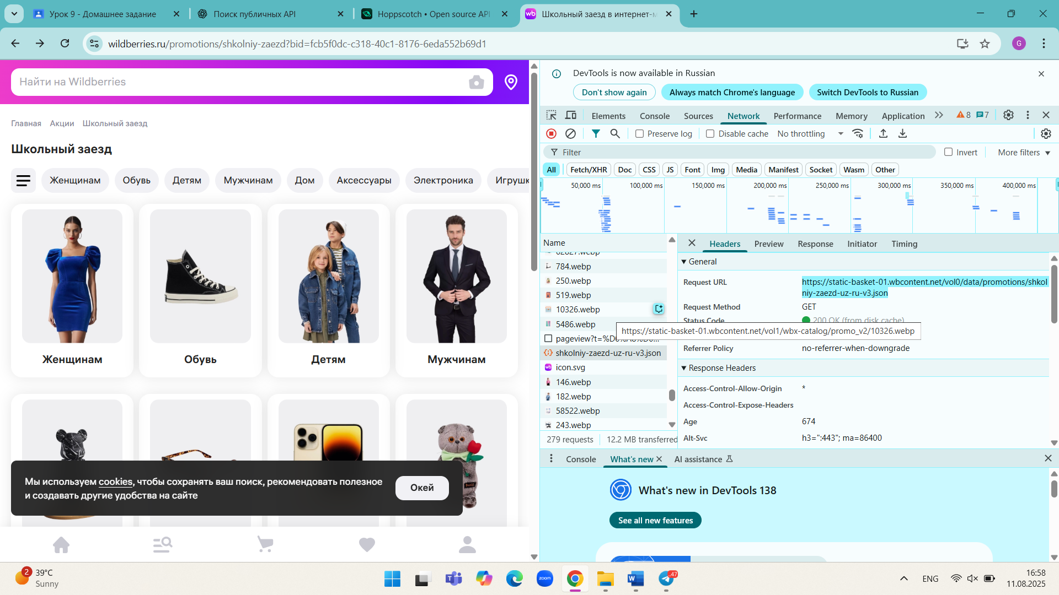

1. Mediapark popular products

**URL:** https://api.v2.mediapark.uz/v1/popular-product-words

**Метод:** get

**Статус код:** 200 OK

